WWII- Georgia War Effort and Effects on Economy and People
Directions: Read the article and answer the questions below in Part 1 and Part 2
SS8H9 Describe the role of Georgia in WWII. b. Evaluate the purpose and economic impact of the Bell Bomber Plant, military bases, and the Savannah and Brunswick shipyards.
From building aircraft and Liberty ships to the quality training that the infantry received, GA’s military support in the war effort was essential to the Allied success of World War II.
In the short term, the arrival of the Bell Bomber plant in Marietta, Georgia, was important for the production of the B-29 bomber, a bomber that was America’s most technologically advanced of the war. Bell paid excellent wages, and its workers (including women and African Americans) were able to produce over 650 of the bombers before the end of World War II. These planes were used in World War II and later in the Korean War.
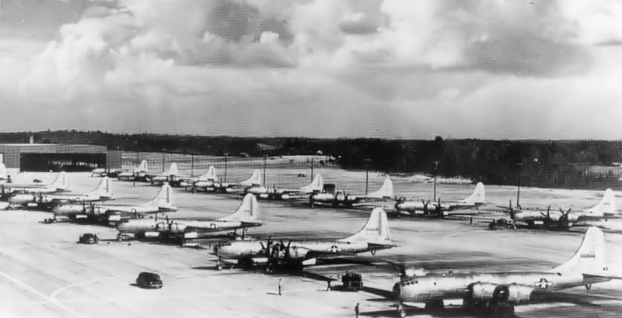
However, the Bell Bomber company had an even more important impact on the economy of Georgia. During the war, almost 30,000 people, many from Georgia, were employed at the largest plant to have ever been built in the Deep South. This transformed Marietta into a major industrial center. Today, the facility houses the Lockheed Martin Company, an aerospace-based company that continues to provide employment for Georgians.
B-29B Superfortress bombers at the Bell Bomber plant 1945
During World War I there were more military facilities in Georgia than any other state. During World War II, due to the number of men and women in uniform, many of these bases grew in size. They played an important role in training and supplying the military during the war. For example, Fort Benning near Columbus, Georgia, was the largest and viewed as the best infantry facility during the war. Interestingly, these bases also held thousands of enemy prisoners. Today, these bases provide thousands of jobs for Georgians and pump millions of dollars into the state’s economy.
A major contribution during the war came from the large number of civilians (many women) who built liberty ships during the war. These cargo ships were used to transport troops and supplies(grain, trucks, mail, etc.) to both the European and Pacific fronts. In all, 187 ships used during the war were built in either Savannah or Brunswick, Georgia’s two deep-water sea ports. Georgia’s ships came to be called “Liberty Ships” because President Roosevelt said they would, “bring liberty to Europe!”
The economic impact of the Savannah and Brunswick shipyards on Georgia communities was huge. More than 15,000 employees, many of which were women, built 88 Liberty ships at the Savannah shipyard. The J. A. Jones shipyard in Brunswick turned out 99 Liberty ships in just two years. Local economies were boosted when thousands of Georgia citizens earned paychecks that were ultimately re-invested in community businesses.
PART 1 Directions: Copy the vocabulary below and fill in the blanks with the correct words.
- _______ _______plant- factory located in__________, Georgia, that produced ________ bombers during WWII
- ___________ Ships - U.S. _______ ships made during World War II. In all ______ of these ships were made in Georgia in either _____________ or ______________, Georgia’s two ________-water ______ ports
PART 2 Directions: Fill in each shape with the correct information. SUMMARIZE and use your own words! Don’t copy verbatim (word-for-word) from the article!

What was done to support the war effort? When? Where? What was the outcome? | How was Georgia impacted economically? What was the effect of this war effort on Georgia (then and now)?
