.

**Carl Vinson**

Richard B. Russel, Jr.

* Richard B. Russell, Jr. (1897-1971) was a governor and senator of GA
* Russell served on the Senate Naval Affairs Committee and during WWII, he often traveled to visit US troops.
* He was an advocate for a strong military in the 1930’s and helped the U.S. prepare to fight in WWII
* He was one of the first politicians to argue that the US needed military bases in foreign territories to secure international security.
* Russell was also influential in bringing or maintaining 15 military bases in Georgia, along with many other research facilities, including the Centers for Disease Control, and federal funding of other projects throughout the state. This attention to the acquisition of military installations for the state had a major long-lasting economic impact.
* Carl Vinson (1881-1983) was first elected to the Georgia General Assembly in 1908, and then was elected to the House of Representatives in 1914, where he served for 50 years—longer than any other congressman.
* Vinson served on the House Naval Affairs Committee where he won the nickname, “the father of the two-ocean navy.”
* For decades, he argued that the US must strengthen its navy if it hoped to remain secure. During the isolationist period of the 1920’s his ideas were ignored, but as war began to rage the nation began to accept his policies
* Vinson pushed through Congress two bills to expand naval aviation- building planes, training pilots, and establishing air bases and naval facilities. He also encouraged construction at military bases. Both policies created numerous jobs for Georgia civilians and had long-term positive impacts for local communities

[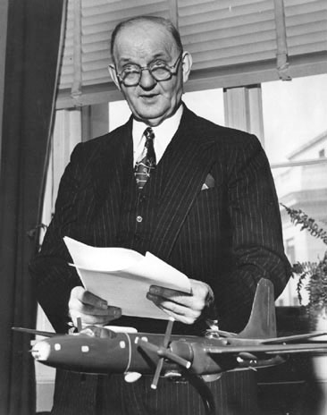](https://ss8h9.wordpress.com/carl-vinson-2/) [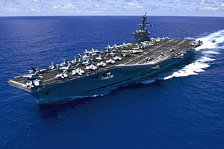](https://en.wikipedia.org/wiki/USS_Carl_Vinson)

[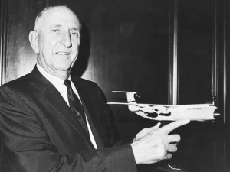](https://russellregionalairport.com/about/history/)



Draw a small symbol that will help you remember why each military man is important to GA’s history and growth

Here Lies:

_______________________________

Born:

Died:

Famous For:

Remembered by Georgia For:

Here Lies:

_______________________________

Born:

Died:

Famous For:

Remembered by Georgia For: