SIMILARITIES AND DIFFERENCES BETWEEN THE GEORGIA AND U.S. CONSTITUTIONS

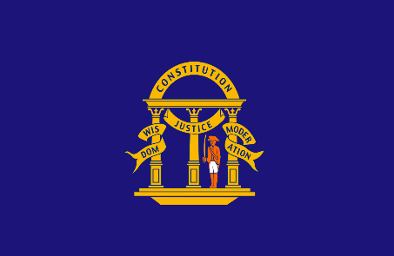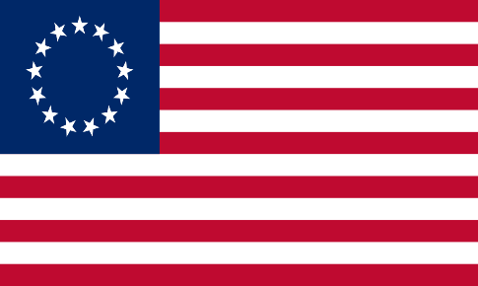

The Georgia Constitution contains many similarities as well as differences to the U. S. Constitution.

Similarities include:
• Each constitution contains a bill of rights.
• Each adopts the concept of separation of powers with specific legislative, executive and judicial branches.
• Executive leaders have power to appoint officials and veto bills.
• The legislative branches (the U.S. Congress and the Georgia General Assembly) are bicameral and each calls its two chambers the Senate and the House of Representatives.
• Both governments allow judicial review (the power of the courts to declare acts unconstitutional.)

Differences include:
• Georgia’s Constitution is longer in length due to the specific, detailed policies.
• Georgia voters must approve any amendments to the constitution while there is no comparable role for amending the U. S. Constitution.
• Georgia’s Constitution requires that the state maintain a balanced budget while the U.S. Constitution does not place that limitation on the federal government.
• According to the Georgia Constitution, the Georgia Governor has line-item veto power (can cut a specific item in a spending bill) while the U. S. President does not have the same power.
• Georgia elects almost all of its judges on non-partisan ballots while the President nominates judges for Senate approval.
• Legislators (both Senators and Representatives) in Georgia serve two-year terms while at the national level, Representatives serve two-year terms and Senators serve six-year terms.
• The Georgia Governor does not function with a cabinet of advisors as does the President.
• The Georgia Constitution provides detailed information regarding how local governments should function. The U. S. Constitution does not mention local government.

